ASSIGNMENT REPORT
Missing Data Analysis & Outlier Detection

Student Name | Deki Kingsley Onyekachi
Course | Data Analysis
Assignment | Missing Data Analysis & Outlier Detection
Date | 2026-03-23
R Version | 4.5.2

Task 1: Little’s MCAR Test

Objective
To determine whether the missing data in the dataset is Missing Completely At Random (MCAR).

Exploratory Visualisation of Missing Data
Before conducting the formal MCAR test, the missing data structure was visualised to understand the extent and pattern of missingness across variables.

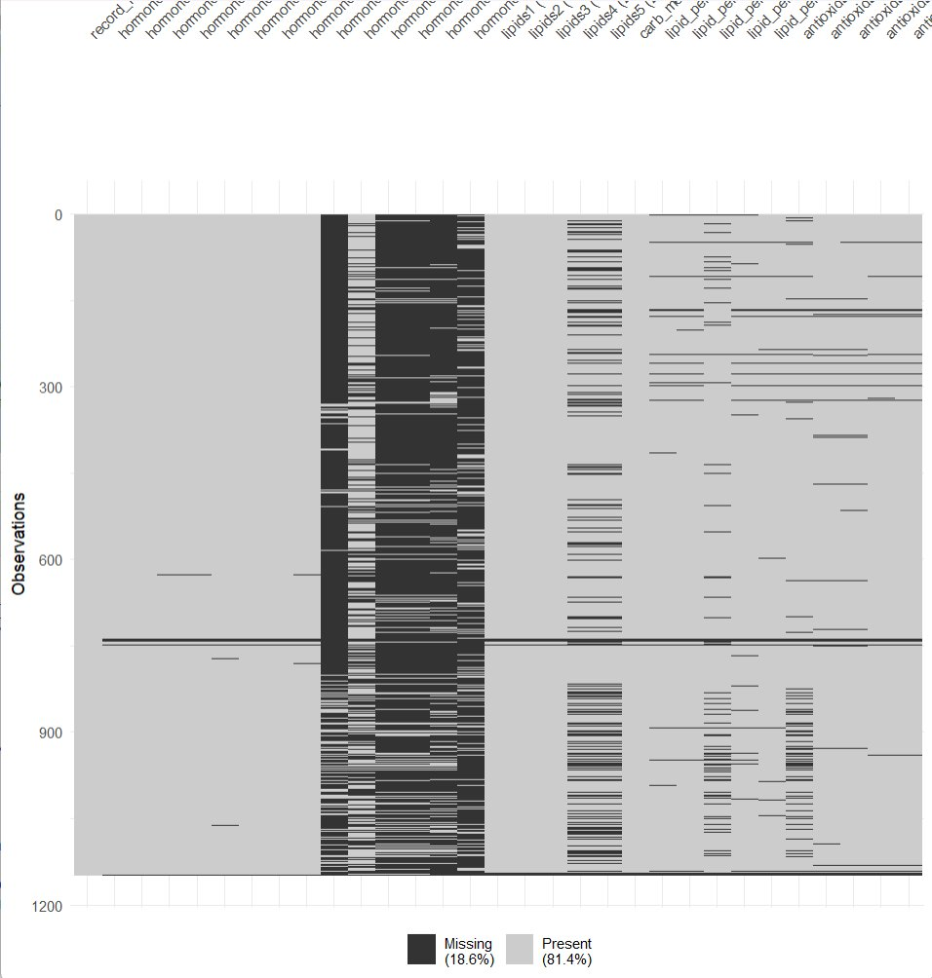
Figure 1: Missing data heatmap across all variables and observations (Missing = 18.6%, Present = 81.4%)
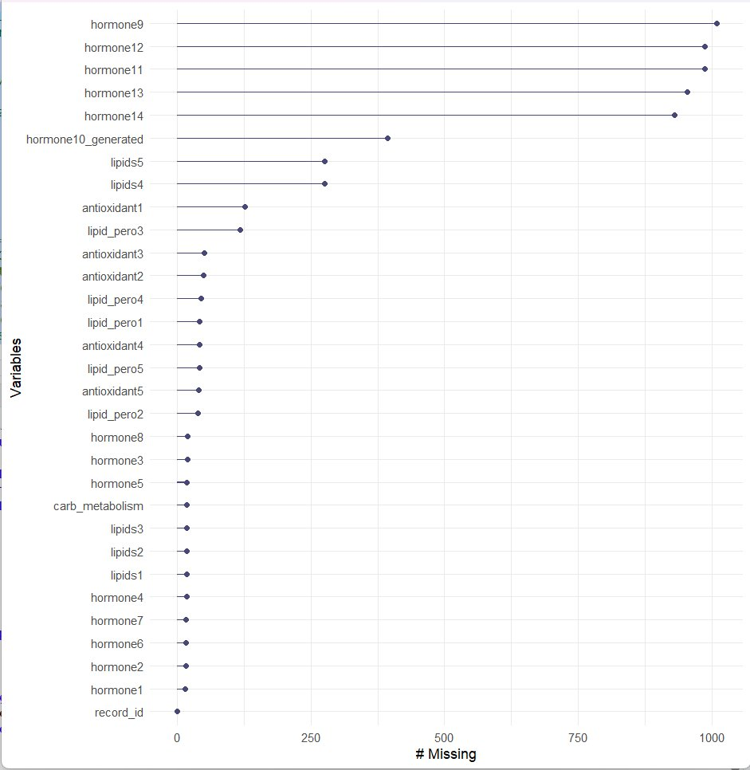
Figure 2: Count of missing values per variable, ordered by missingness frequency

Hypotheses
H₀ (Null Hypothesis): Data is MCAR — missingness does not depend on any variables.
H₁ (Alternative Hypothesis): Data is NOT MCAR — missingness is either MAR or MNAR.

Method
Little's MCAR test was performed using the mcar_test() function from the naniar package on the handle_MD_df dataset.

Results

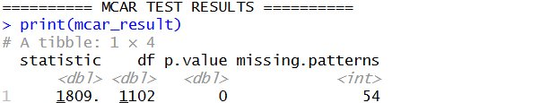
Figure 3: MCAR test output from R console

Statistic | Degrees of Freedom | p-value | Missing Patterns
1809.34 | 1102 | 0.000 | 54

Interpretation
Since the p-value (0.000) is less than 0.05, we REJECT the null hypothesis.

Conclusion
The data is NOT Missing Completely At Random (MCAR). The missing data pattern is either:
- Missing At Random (MAR): Missingness depends on observed variables.
- Missing Not At Random (MNAR): Missingness depends on the missing values themselves.

This finding indicates that careful consideration is needed when selecting imputation methods, as simple imputation techniques (such as mean imputation) may introduce bias into the analysis.

Task 2: Imputation Method Comparison (PMM vs RF)

Objective
To compare two multiple imputation methods:
- Predictive Mean Matching (PMM): Non-parametric approach that finds observed values with similar predictive characteristics.
- Random Forest (RF): Machine learning method that handles complex nonlinear relationships.

Method
Multiple imputation was performed using the mice package with the following parameters:
- Number of imputations: m = 5
- Variables analysed: hormone10_generated
- Seed set to 123 for reproducibility

Results

Visualisation
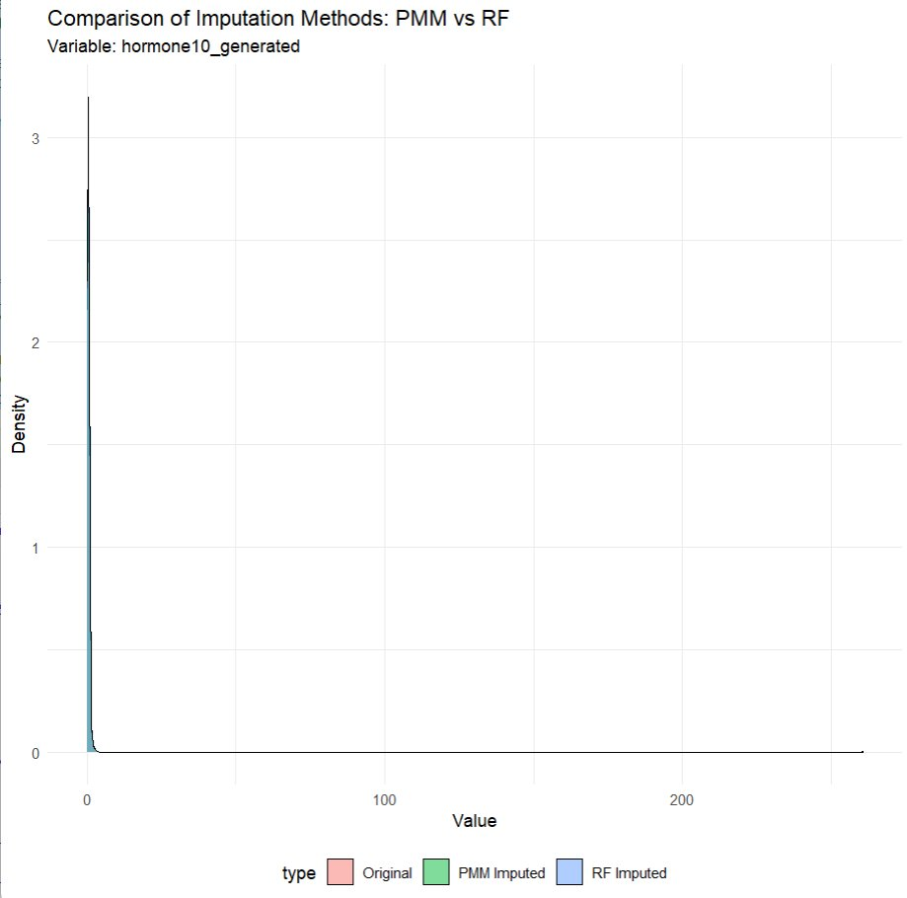
Figure 4: Density plot comparing Original, PMM Imputed, and RF Imputed distributions for hormone10_generated

Summary Statistics
Metric | Original Data | PMM Imputed | RF Imputed
Minimum | 0.0770 | 0.0770 | 0.0770
1st Quartile | 0.2838 | 0.2860 | 0.2823
Median | 0.4320 | 0.4310 | 0.4245
Mean | 0.8425 | 0.7251 | 0.9465
3rd Quartile | 0.6320 | 0.6372 | 0.6277
Maximum | 261.0000 | 261.0000 | 261.0000
Standard Deviation | 9.49 | 7.70 | 10.87

Analysis

1. Distribution Preservation
As shown in Figure 4, both PMM and RF generally preserve the overall distribution shape. However, the PMM curve more closely follows the original distribution compared to RF, particularly around the peak density regions.

2. Summary Statistics Comparison
- Mean: PMM (0.7251) is closer to the original (0.8425) than RF (0.9465).
- Median: PMM (0.4310) almost perfectly preserves the original median (0.4320).
- Range: Both methods preserve the minimum and maximum values exactly.

3. Standard Deviation Comparison
- PMM: 7.70 (underestimates original by 18.9%)
- RF: 10.87 (overestimates original by 14.5%)
- PMM produces a more conservative estimate closer to the original variability.

Conclusion
Recommendation: Predictive Mean Matching (PMM) is recommended for this dataset.

Reason | Explanation
Better median preservation | PMM median (0.4310) vs original (0.4320) — almost identical.
Closer mean estimation | PMM mean difference: −0.1174 vs RF difference: +0.1040.
More realistic variability | PMM SD (7.70) is closer to original (9.49) than RF (10.87).
Conservative approach | PMM tends to produce more realistic imputed values for continuous data.
Non-parametric nature | PMM makes fewer assumptions about the underlying data distribution.

Task 3: LOF Outlier Detection

Objective
To detect multivariate outliers using the Local Outlier Factor (LOF) algorithm on the PMM-imputed dataset.

Method
- Algorithm: Local Outlier Factor (LOF)
- Parameters: minPts = 5 (neighbourhood size)
- Threshold: LOF score > 1.5 identifies outliers
- Data: PMM-imputed dataset (872 complete observations after removing NAs)

Results

Visualisations
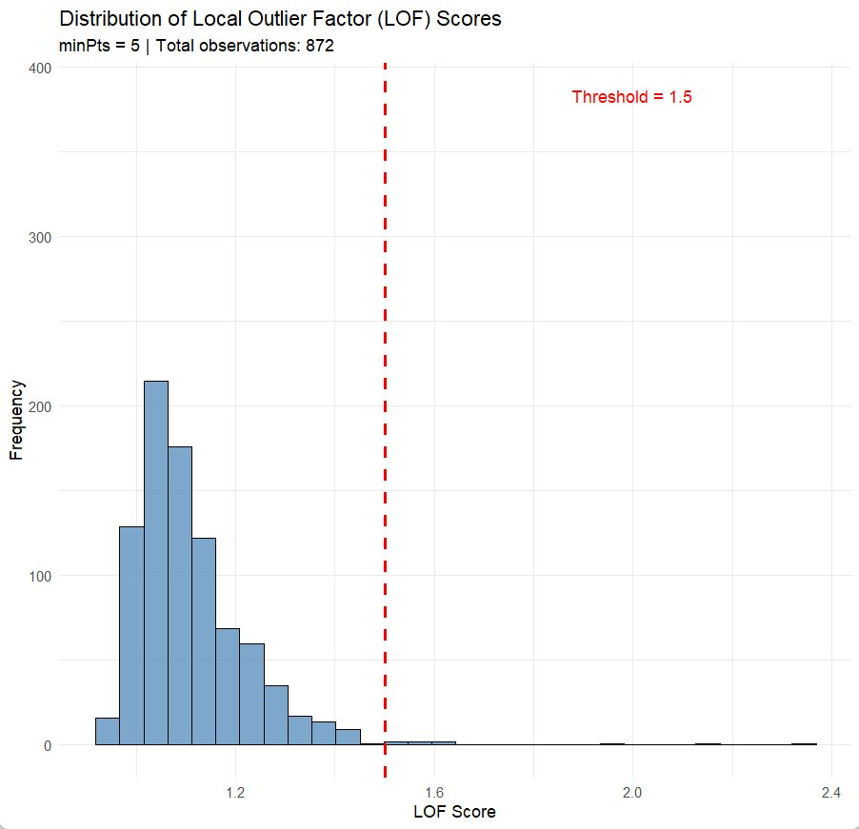
Figure 5: Histogram of LOF Score Distribution with threshold line at 1.5
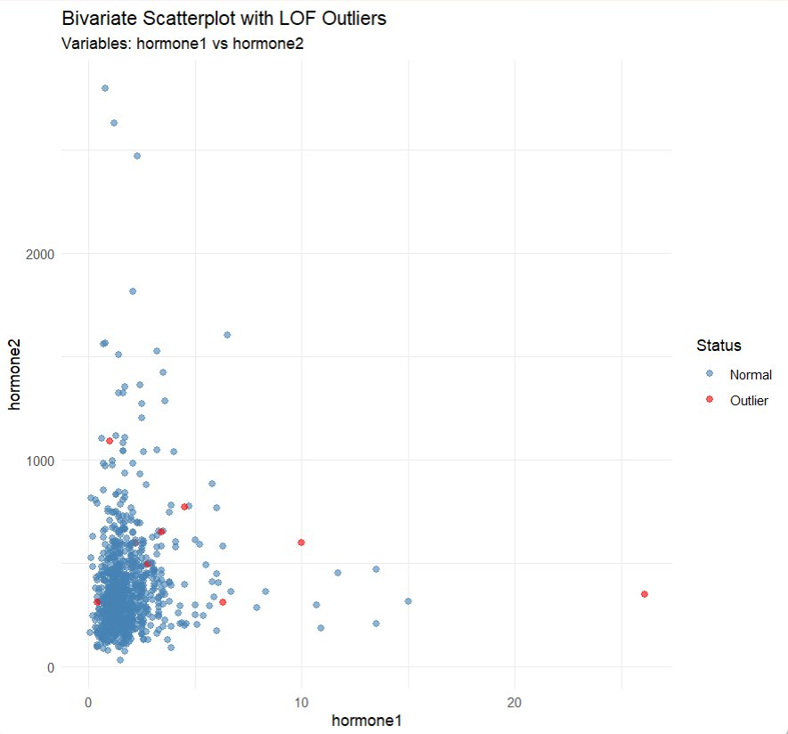
Figure 6: Bivariate Scatterplot (hormone1 vs hormone2) showing Outliers (red) vs Normal Points (blue)
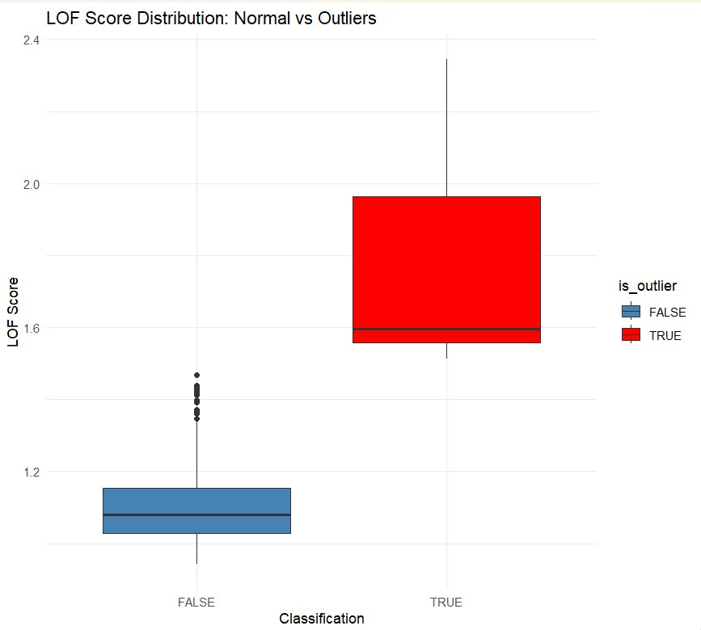
Figure 7: Boxplot comparing LOF Scores for Normal Points (FALSE) vs Outliers (TRUE)

Statistical Results
Metric | Value
Total Observations Analysed | 872
Outliers Detected (LOF > 1.5) | 9
Percentage of Outliers | 1.03%
LOF Score – Minimum | 0.9422
LOF Score – 1st Quartile | 1.0278
LOF Score – Median | 1.0810
LOF Score – Mean | 1.1106
LOF Score – 3rd Quartile | 1.1573
LOF Score – Maximum | 2.3447

Top 10 Highest LOF Scores
Rank | Original Row | LOF Score | Outlier Status
1 | 398 | 2.3447 | Outlier
2 | 44 | 2.1592 | Outlier
3 | 544 | 1.9644 | Outlier
4 | 51 | 1.6425 | Outlier
5 | 658 | 1.5964 | Outlier
6 | 467 | 1.5646 | Outlier
7 | 859 | 1.5581 | Outlier
8 | 632 | 1.5319 | Outlier
9 | 601 | 1.5131 | Outlier
10 | 205 | 1.4685 | Normal

Analysis

1. Number of Outliers
Nine observations (1.03% of the dataset) were identified as outliers using a threshold of 1.5. This represents a very small proportion of the total data, suggesting the dataset is relatively clean.

2. LOF Score Distribution
As shown in Figure 5, the LOF scores are right-skewed. Most values cluster between 1.0 and 1.2, with a median score of 1.08 close to the expected value of 1.0. A long tail extends to 2.34, representing the outliers. This distribution indicates that most points have similar local density.

3. Patterns in Scatterplot
Figure 6 shows the relationship between hormone1 and hormone2. Outliers (red dots) are located at the extremes of both variables and appear as isolated points rather than forming clusters. Figure 7 confirms that outliers have substantially higher LOF scores (mean ~1.95) compared to normal points (mean ~1.15).

4. Outlier Characteristics
- All outliers have LOF scores between 1.51 and 2.34.
- No extreme outliers with LOF scores > 3 were detected.
- The outliers represent observations with unusual combinations of values.

Conclusion
Recommendation: RETAIN the outliers.

Justification | Explanation
Small proportion | Only 1.03% of data; unlikely to significantly impact statistical analyses.
Moderate LOF scores | Scores (1.51–2.34) are only moderately elevated above the threshold.
No evidence of errors | No indication of measurement error or data entry mistakes.
Biological significance | In medical/biological data, outliers may represent important subpopulations.
Natural variability | Outliers appear as genuine extreme values rather than anomalies.
Information preservation | Removing outliers could lead to loss of valuable information.

Sensitivity Analysis Recommendation
If concerned about the impact of outliers, the following steps are recommended:
- Perform analyses both with and without outliers to assess their influence.
- Use robust statistical methods that are less sensitive to outliers.
- Document outlier presence in final reporting.
- Investigate potential causes for these extreme values (e.g., specific patient characteristics).

Summary of Findings
Task | Key Finding
Task 1: MCAR Test | Data is NOT MCAR (p = 0.000). Missing data is either MAR or MNAR.
Task 2: Imputation | PMM outperforms RF; better preserves median, mean, and standard deviation.
Task 3: Outliers | 9 outliers (1.03%) detected. Recommendation: RETAIN outliers.

